CCW-MIRAPLY-V
MATERIAL CERTIFICATION

This is to certify that CCW MiraPLY-V is a vertical grade, self-adhering membrane that is comprised of a tough, durable and flexible reinforced TPO backing with a butyl alloy adhesive designed for blindside waterproofing in below-grade construction. CCW MiraPLY is manufactured in the USA.

CCW manufactures CCW MiraPLY-V Membrane to comply with the following ASTM typical property values and meets the specification requirements:
CCW-MiraPLY-V-Property | Test Method | Unit | Typical Value*
TPO |  | mils (mm) | 45 (1.14)
Butyl Alloy |  | mils (mm) | 25 (.64)
Thickness | ASTM D 1970 | mils (mm) | 70 (1.78)
Water Vapor Transmission | ASTM E 96 B | perms | 0.090
Tensile Strength | ASTM D 882 | psi | 1,500
300% Modulus | ASTM D 412 | psi | 1,000
90⁰ T-Peel | ASTM D 1876 | lb. | 15.0
Elongation @ Break @ 23⁰C (Die C) | ASTM D 412 | % | 325
Flexibility Temperature @ -29⁰C (-20⁰F) | ASTM D 1970 | Pass/Fail | No Cracking - Pass
Hydrostatic Pressure Resistance | ASTM D 5385 | ft. | >231 (100 psi)
Peel Strength Over Poured Concrete (tested w/2” strips) | ASTM D 903 | lb. | 5.6
Puncture Resistance Load at Puncture | ASTM E 154 | lb. | 375
Tear Strength | ASTM D 624 | psi | 1,000
Soil Decay Testing – E 96 Permeance | ASTM E 154 | - | pass
Soil Decay Testing – Weight Loss | ASTM D 154 |  | Pass
Lateral Water Migration Resistance | ASTM D5385  modified | psi | Pass at 100 psi (231 ft) of hydrostatic pressure
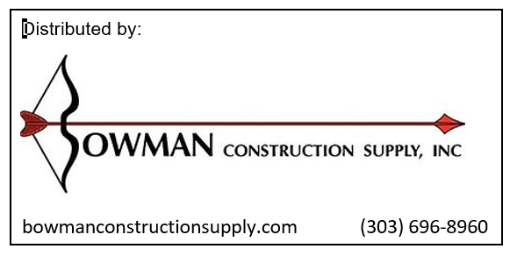
Rev. January 18, 2016

